**Servo Tuning**

Apply to: Kinetix 5500, Kinetix 5700

Date: June 26, 2018

1. **General Setting**
   1. Set application type: Constant Speed
   2. 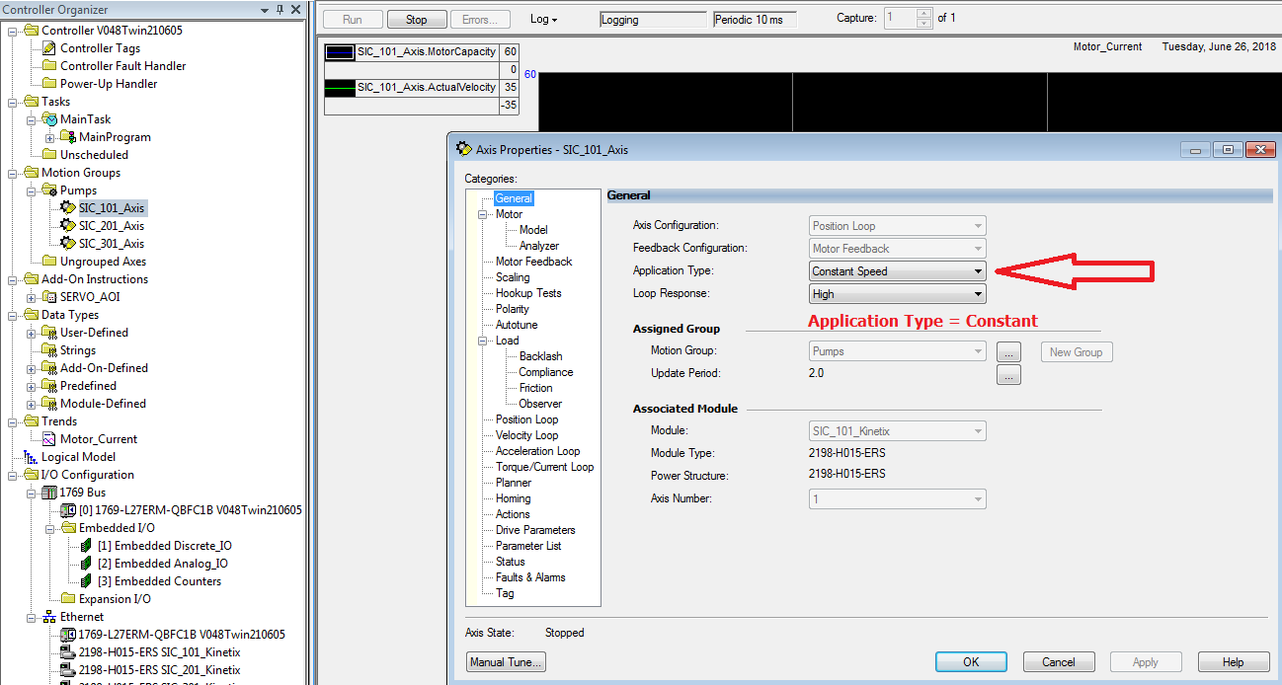Loop response: High
2. **Scaling Factor**
   1. This scaling parameter is the gear reduction. It could be found in the pump datasheet (line 11 in this case)



* 1. If the scaling factor in servo axis set as 1, then the ratio could be found in ladder logic code. (The scaling factor could be set at either place)

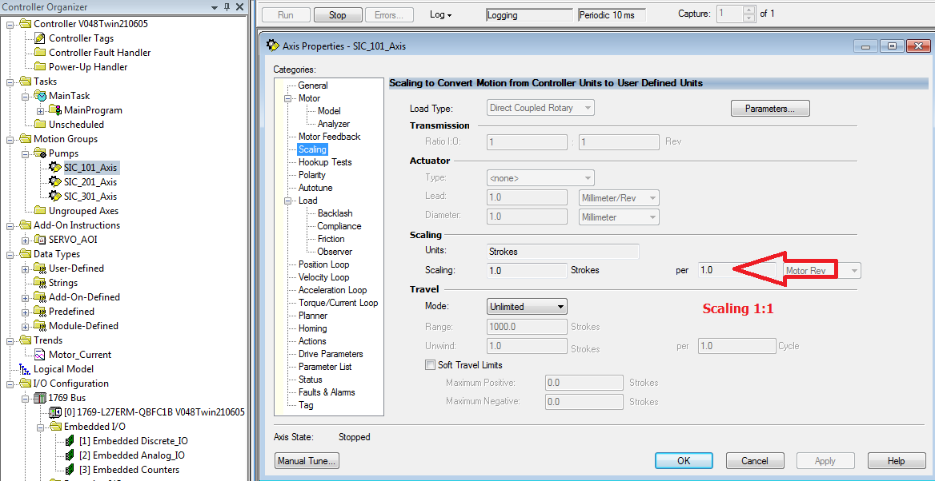

* 1. 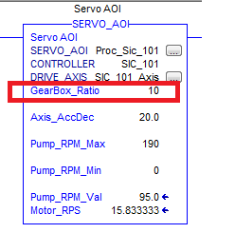The scaling factor set as “10” in ladder logic code in this case.

1. 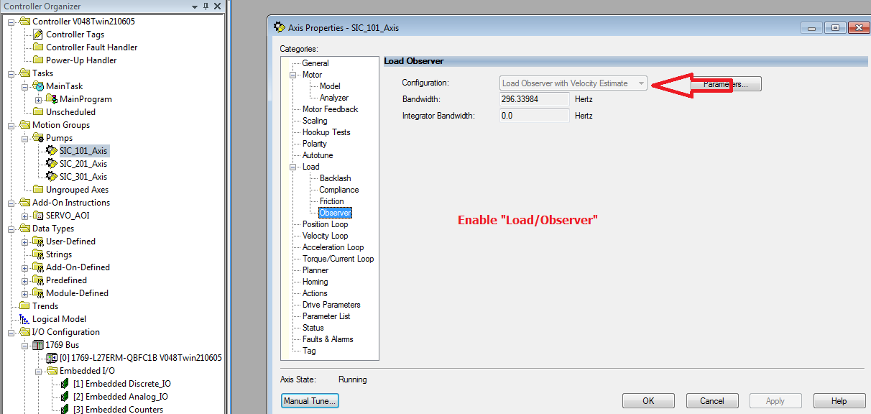**Set up observer**
   1. Set the configuration as “Load Observer with Velocity Estimate”
2. 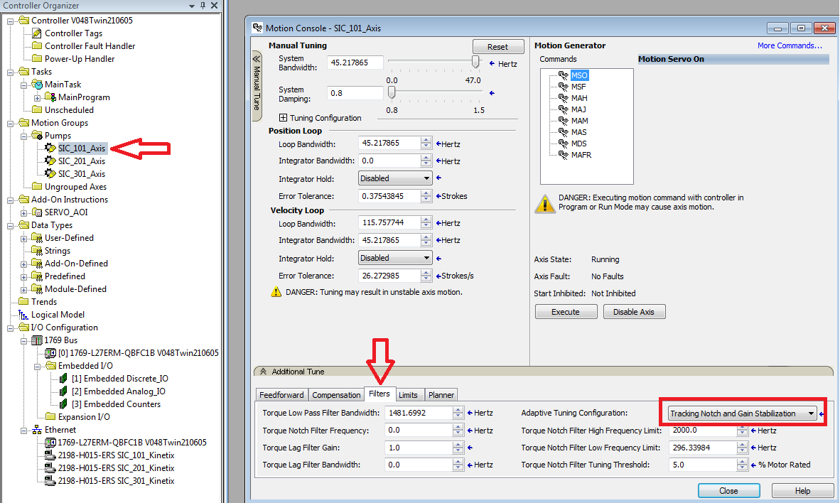Additional Tune
   1. Select “tracking notch and gain stabilization”
   2. set “Velocity Feed Forward” to:  **50% (not sure about this since Brian did not mention it)**
3. **Setup Position Tolerance**
   1. Typical value is about 1/3 strokes.

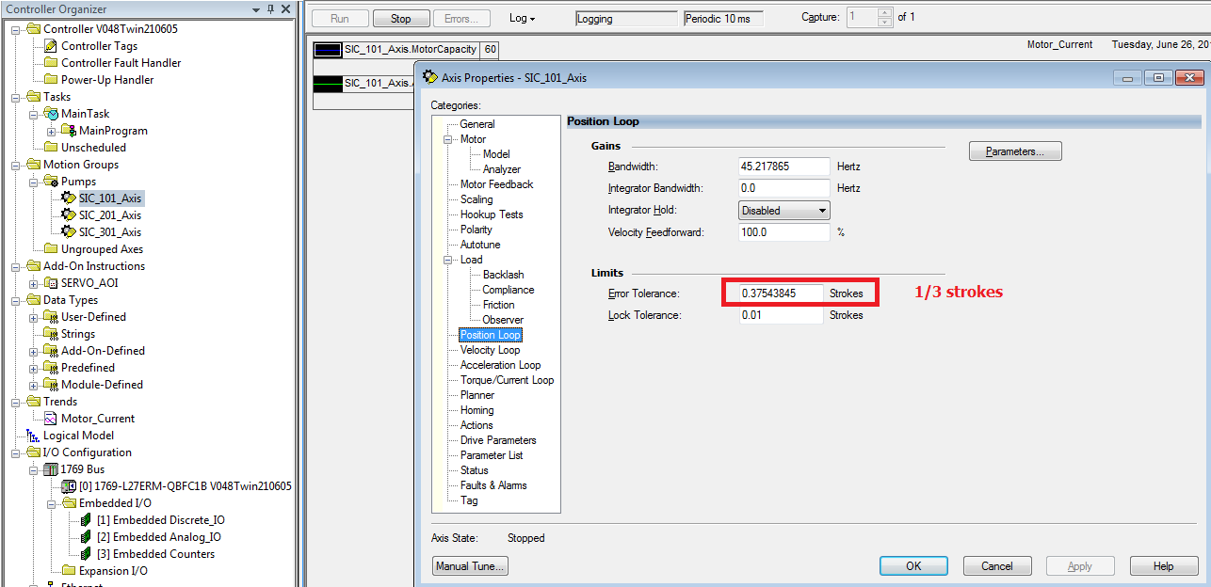

1. **Observe the performance**
   1. 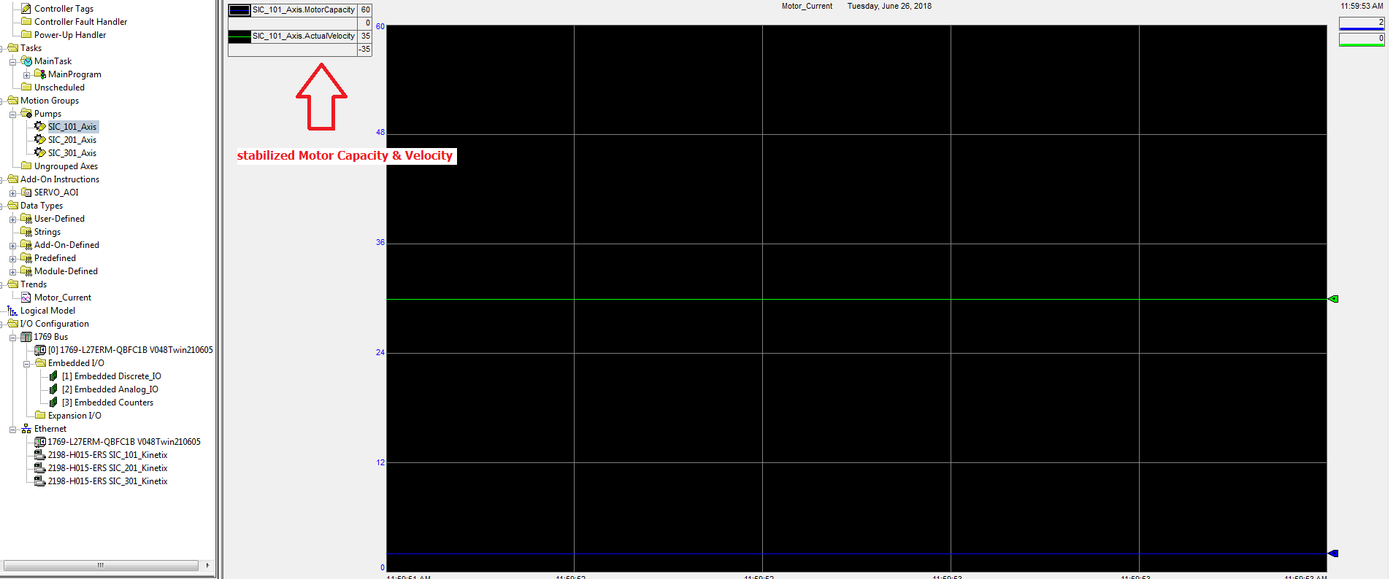set up the trend with pens
2. **Calculate the peak torque limit (important!!!)**
   1. Calculation details could be found in the excel sheet

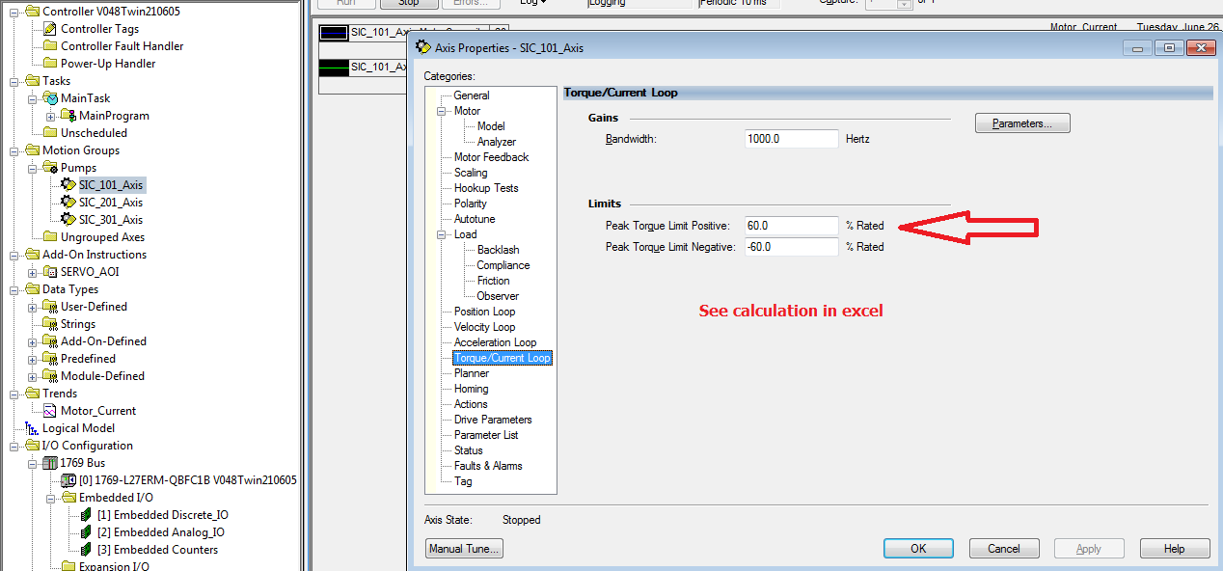

**8 Set Torque low pass filter bandwidth**

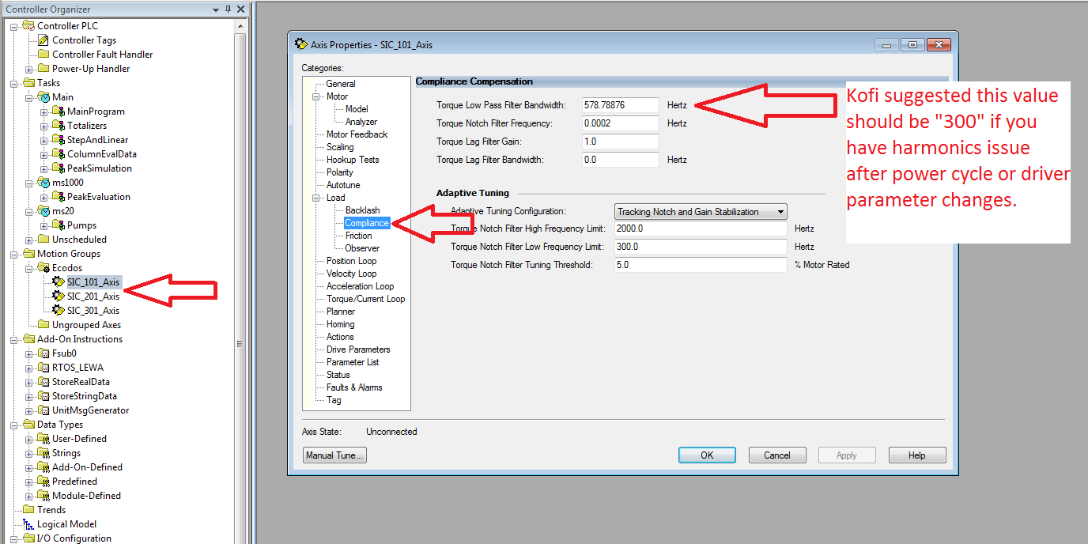

**9 Set Torque Notch Filter Frequency** (To prevent noise on the drives. Noise would only occur on the first run of the pump after a power cycle and not the subsequent runs. The Notch Filter Frequency is a dynamic value that should be captured and stored automatically in the Servo axis using a ladder code from the “ServoNotchFilterFrequencyCapture” AOI)

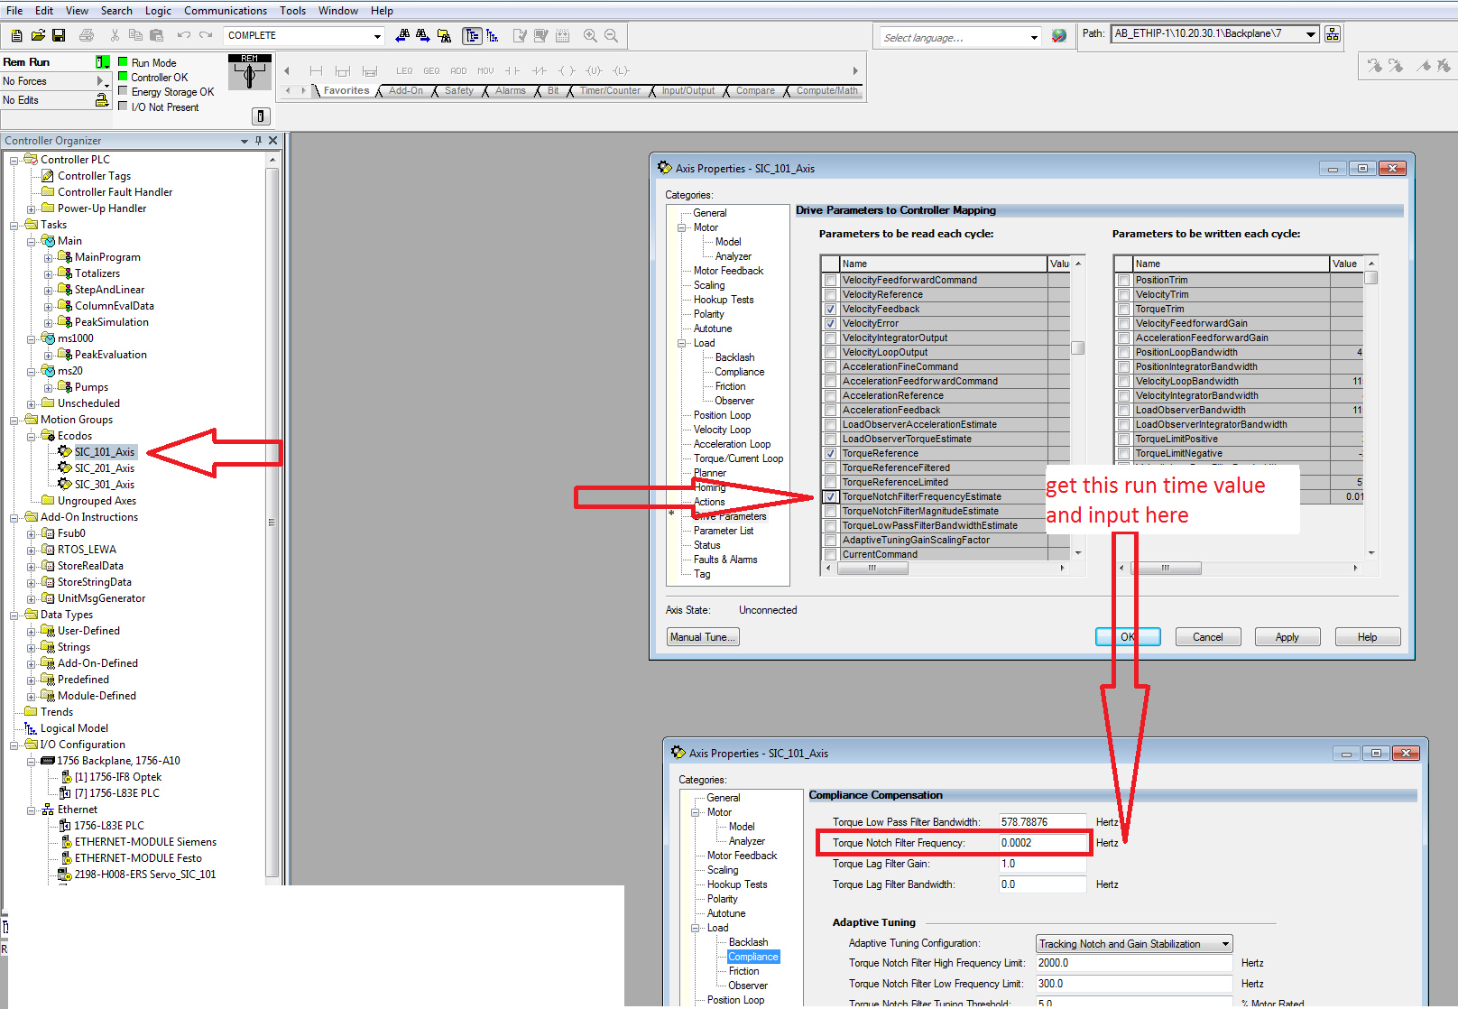

**Cat. NO. 2198-H040-ERS:** This motor has a different winding causing it to require different settings from previous servo system settings. the changes made here is meant to mitigate motor startup noise issues.

1. Set “General/Loop Response to Medium”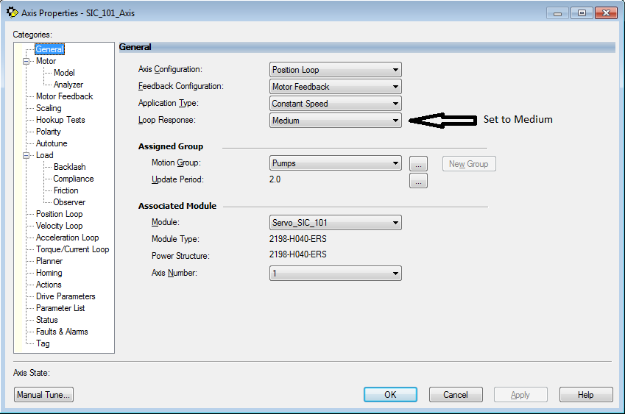
2. Enable “Drive Parameters/TorqueNotchFilterEstimate”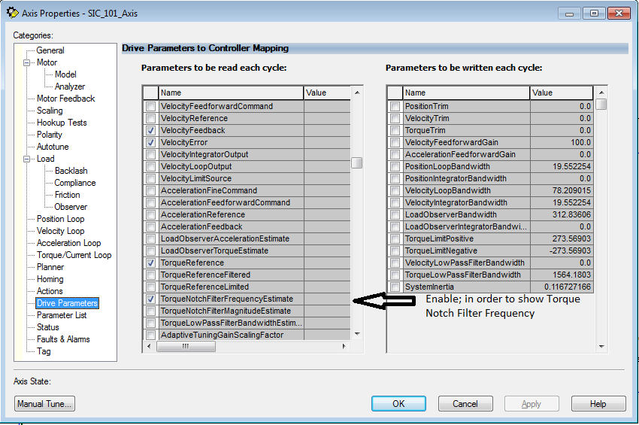
3. Set “Load/Observer/Configuration” to Load Observer With Velocity Estimate.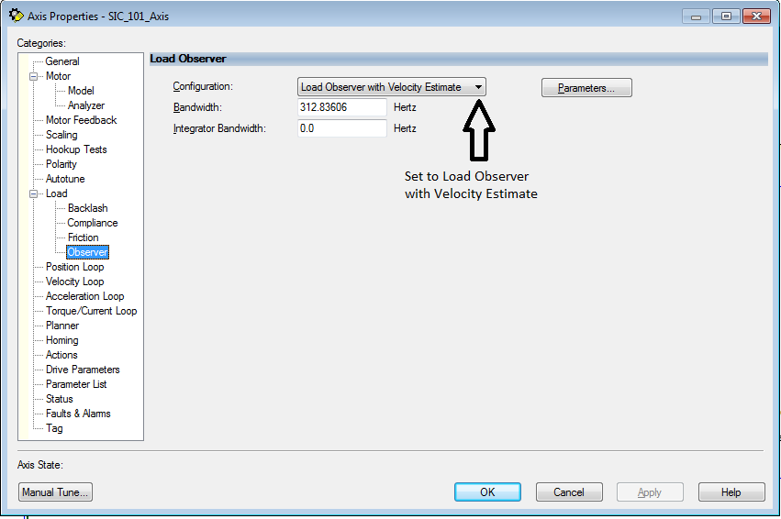
4. Code auto Notch Filter Frequency Capture code within the drive code, an AOI exists that could be used. This section of code should be disabled until the drive noise is only present at startup and only about same frequency value when the noise occurs.

